1. It was a good thing that…答案
2. It is very important that …
3. course outline n 课程大纲
4. We could’ve done a bit more work in the beginning.
5. could have done 本可以
6. a whole load of work 超多的工作
7. group/ group discussion
8. What was good about some sessions is …
9. handout n 讲义
10. written work 写的作业
11. entitle v 使享有…
12. entry n 进入 entrance n 入口
13. peak times 高峰期  
    地图题表达

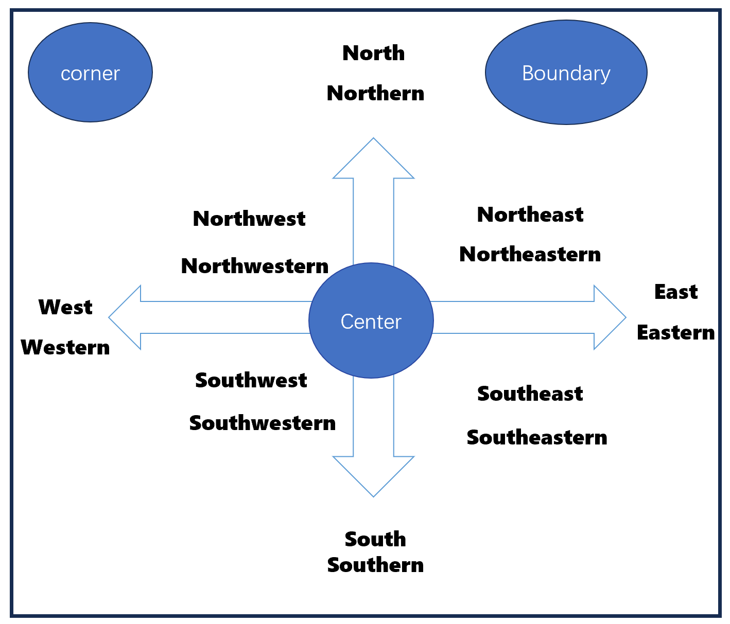

1. on the far side 在…远端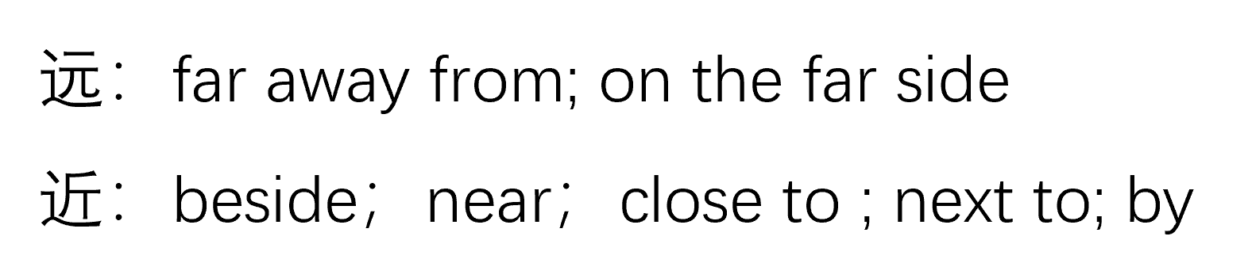
2. on the other side of … 在…的另一边
3. on the same side of… 在同一边
4. overlook v 俯瞰
5. opposite prep 在对面
6. ahead of sb 在前面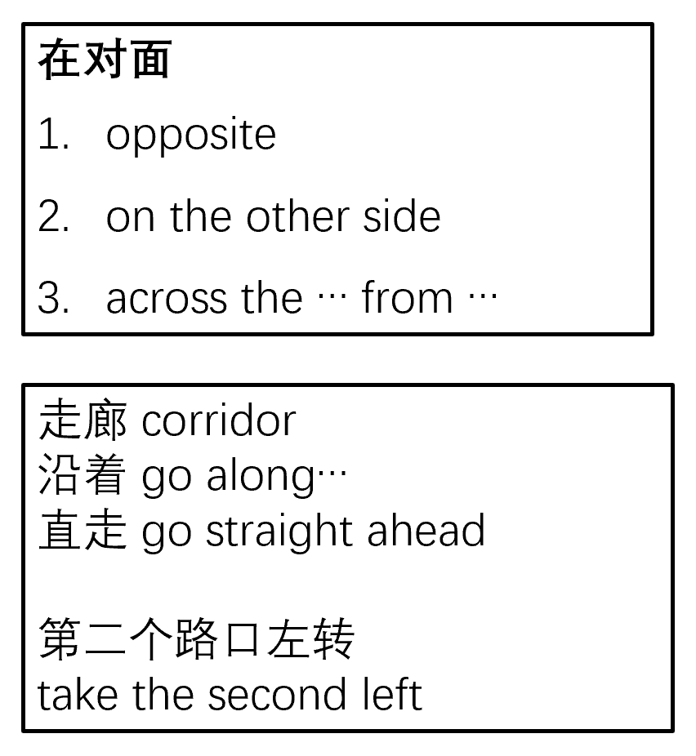
7. junction n 丁字路口 ；枢纽
8. Fairly close to where our refreshments are available, there’s a dog
9. available adj 可获得的
10. surround v 环绕
11. display v 展示
12. that’s quite a walk. 很长一段路
13. go past mountain road.
14. hire v 租 = rent hire v 雇佣
15. 没有名字的路： little road, footpath, track
16. behind 在…后面